|  |  |
| --- | --- |
| 1.1 Student name | **Đào Ngọc Tuấn Anh** |
| 1.3 Which Exercise is this? | 1. **Create a PhoneGap App utilizing the Notification API**   Create a PhoneGap App that shows a confirmation dialog box to prompt users to push one button to ring a bell, and another button for vibrate. |
| 1.4 How well did you complete the exercise? Tick as appropriate. | * I tried but couldn't complete it 🞎 * I did it but I feel I should have done better 🞎 * I did everything that was asked 🗹 * I did more than was asked for🞎 |
| 1.5 Briefly explain your answer to question 1.4 | Exercise’s requirements are basically satisfied. Can be improved with the stylesheet or use a button to make the dialog appears instead of instant appears |

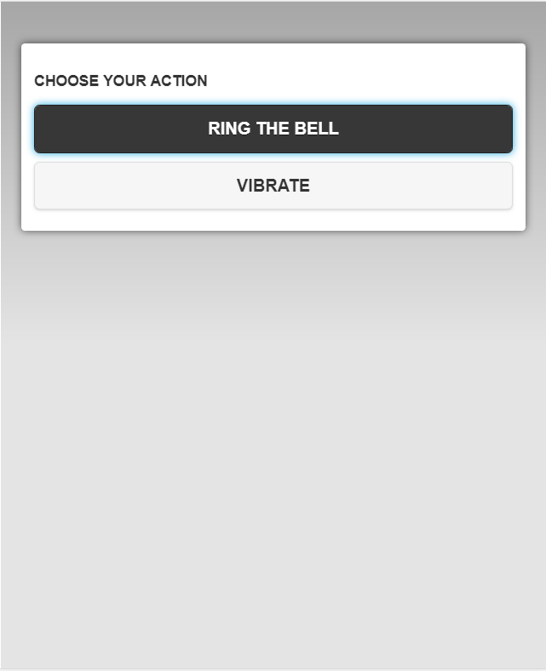

*<head>*

*<meta charset="utf-8" />*

*<meta name="format-detection" content="telephone=no" />*

*<meta name="msapplication-tap-highlight" content="no" />*

*<meta name="viewport" content="user-scalable=no, initial-scale=1, maximum-scale=1, minimum-scale=1, width=device-width" />*

*<link rel="stylesheet" href="http://code.jquery.com/mobile/1.4.5/jquery.mobile-1.4.5.min.css" />*

*<script src="http://code.jquery.com/jquery-1.11.1.min.js"></script>*

*<script src="http://code.jquery.com/mobile/1.4.5/jquery.mobile-1.4.5.min.js"></script>*

*<link rel="stylesheet" type="text/css" href="css/index.css" />*

*<title>Ring and vibrate</title>*

*</head>*

*<div data-role="dialog" id="sure" data-title="Choose your action">*

*<div data-role="content">*

*<h3 class="sure-1">Choose your action</h3>*

*<a href="#" data-role="button" data-theme="b" id="ring">Ring the bell</a>*

*<a href="#" data-role="button" data-theme="c" id="vibrate">Vibrate</a>*

*</div>*

*</div>*

*$("#ring").click(function(event) {*

*navigator.notification.beep(1);*

*});*

*$("#vibrate").click(function(event) {*

*navigator.vibrate(3000);*

*});*